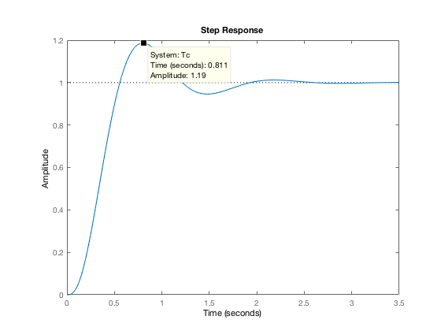Prob 27

PD compensated step response gives settling time just short of 2 seconds. Calculated PD pole at -2.95 with gain of 294.57

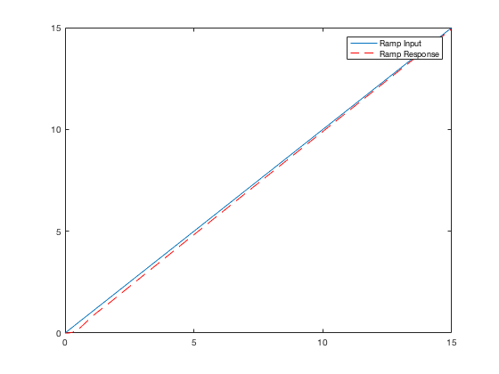

Ramp response to input starts with some lag but converges to input signal within 15 seconds.

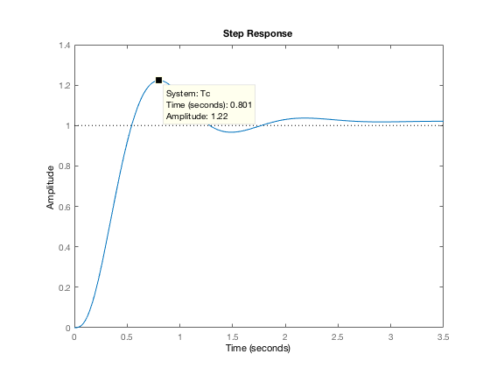Final transfer function gain has 22% OS and settles within the 2 second design criteria.

$$G_{c}\left(s\right)= \frac{296.9 (s+0.1)(s+2.95)}{s}$$

os_pcnt = 25;

t_settle = 2;

zeta = (-log(os_pcnt/100)) / sqrt(pi^2 + log(os_pcnt/100)^2);

sigma = 4/t_settle;

w_d = sigma * tan(acos(zeta));

s_12 = (-sigma + w_d*1i);

ang_con = -(180 + (-angle(s_12) - angle(s_12 + 4) - angle(s_12 + 6) - angle(s_12 + 10))*(180/pi));

p_comp = (w_d / (tand(ang_con)) + sigma);

gain_pd = -real(s_12 * (s_12 + 4) * (s_12 + 6) * (s_12 + 10) / (s_12 + 2.95));

% G = zpk([],[0 -4 -6 -10],1);

% Gc = zpk([-p_comp],[],[gain_pd]);

% Tc = feedback(Gc*G, 1);

% step(Tc)

gain_pid = -real(s_12^2 * (s_12 + 4) * (s_12 + 6) * (s_12 + 10) / ((s_12 + 2.95) * (s_12 + 0.1)));

sprintf('G_c(s) = %1.1f (s + 0.1)(s + %1.2f) / s',gain_pid, p_comp)

G = zpk([],[0 -4 -6 -10],1);

Gc = zpk([-0.1 -p_comp],[0],[gain_pid]);

Tc = feedback(Gc*G, 1);

step(Tc)

figure

t = 0:0.1:15;

u = t;

y = lsim(Tc,u,t);

plot(t,u,t,y,'r--');

legend('Ramp Input','Ramp Response')